Scan Converting a Straight Line
A straight line may be defined by two endpoints & an equation. In fig the two endpoints are described by (x₁,y₁) and (x₂,y₂). The equation of the line is used to determine the x, y coordinates of all the points that lie between these two endpoints.
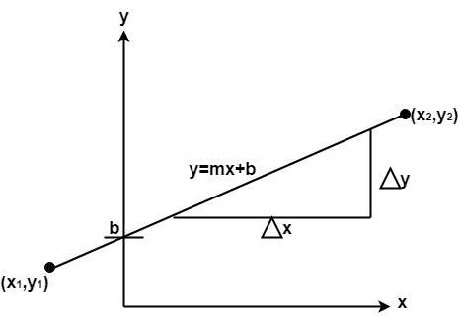
Using the equation of a straight line, y = mx + b where m = & b = the y interrupt, we can find values of y by incrementing x from x =x₁, to x = x₂. By scan-converting these calculated x, y values, we represent the line as a sequence of pixels.

Properties of Good Line Drawing Algorithm:
1. Line should appear Straight: We must appropriate the line by choosing addressable points close to it. If we choose well, the line will appear straight, if not, we shall produce crossed lines.
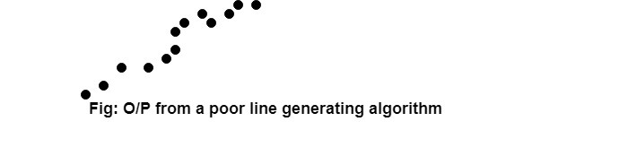
The lines must be generated parallel or at 45° to the x and y-axes. Other lines cause a problem: a line segment through it starts and finishes at addressable points, may happen to pass through no another addressable points in between.
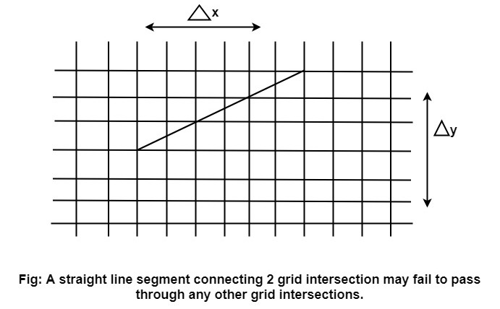
2. Lines should terminate accurately: Unless lines are plotted accurately, they may terminate at the wrong place.
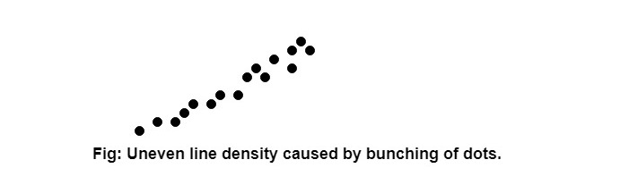
3. Lines should have constant density: Line density is proportional to the no. of dots displayed divided by the length of the line.
To maintain constant density, dots should be equally spaced.
4. Line density should be independent of line length and angle: This can be done by computing an approximating line-length estimate and to use a line-generation algorithm that keeps line density constant to within the accuracy of this estimate.
5. Line should be drawn rapidly: This computation should be performed by special-purpose hardware.

Algorithm for line Drawing:
- Direct use of line equation
- DDA (Digital Differential Analyzer)
- Bresenham's Algorithm

Direct use of line equation:
It is the simplest form of conversion. First of all scan P₁ and P₂ points. P₁ has co-ordinates (x₁',y₁') and (x₂' y₂' ).
Then m = (y₂',y₁')/( x₂',x₁') and b =
If value of |m|≤1 for each integer value of x. But do not consider
If value of |m|>1 for each integer value of y. But do not consider
Example: A line with starting point as (0, 0) and ending point (6, 18) is given. Calculate value of intermediate points and slope of line.
Solution: P₁ (0,0) P₇ (6,18)
x₁=0
y₁=0
x₂=6
y₂=18
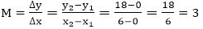
We know equation of line is
y =m x + b
y = 3x + b..............equation (1)
put value of x from initial point in equation (1), i.e., (0, 0) x =0, y=0
0 = 3 x 0 + b
0 = b ⟹ b=0
put b = 0 in equation (1)
y = 3x + 0
y = 3x
Now calculate intermediate points
Let x = 1 ⟹ y = 3 x 1 ⟹ y = 3
Let x = 2 ⟹ y = 3 x 2 ⟹ y = 6
Let x = 3 ⟹ y = 3 x 3 ⟹ y = 9
Let x = 4 ⟹ y = 3 x 4 ⟹ y = 12
Let x = 5 ⟹ y = 3 x 5 ⟹ y = 15
Let x = 6 ⟹ y = 3 x 6 ⟹ y = 18
So points are P₁ (0,0)
P₂ (1,3)
P₃ (2,6)
P₄ (3,9)
P₅ (4,12)
P₆ (5,15)
P₇ (6,18)
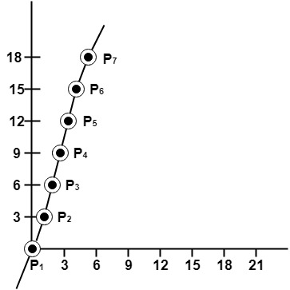

Algorithm for drawing line using equation:
Step1: Start Algorithm
Step2: Declare variables x₁,x₂,y₁,y₂,dx,dy,m,b,
Step3: Enter values of x₁,x₂,y₁,y₂.
The (x₁,y₁) are co-ordinates of a starting point of the line.
The (x₂,y₂) are co-ordinates of a ending point of the line.
Step4: Calculate dx = x₂- x₁
Step5: Calculate dy = y₂-y₁
Step6: Calculate m =
Step7: Calculate b = y₁-m* x₁
Step8: Set (x, y) equal to starting point, i.e., lowest point and x_{end}equal to largest value of x.
If dx < 0
then x = x₂
y = y₂
x_{end}= x₁
If dx > 0
then x = x₁
y = y₁
x_{end}= x₂
Step9: Check whether the complete line has been drawn if x=x_{end}, stop
Step10: Plot a point at current (x, y) coordinates
Step11: Increment value of x, i.e., x = x+1
Step12: Compute next value of y from equation y = mx + b
Step13: Go to Step9.

Program to draw a line using LineSlope Method
- #include <graphics.h>
- #include <stdlib.h>
- #include <math.h>
- #include <stdio.h>
- #include <conio.h>
- #include <iostream.h>

- class bresen
- {
- float x, y, x1, y1, x2, y2, dx, dy, m, c, xend;
- public:
- void get ();
- void cal ();
- };
- void main ()
- {
- bresen b;
- b.get ();
- b.cal ();
- getch ();
- }
- Void bresen :: get ()
- {
- print ("Enter start & end points");
- print ("enter x1, y1, x2, y2");
- scanf ("%f%f%f%f",sx1, sx2, sx3, sx4)
- }
- void bresen ::cal ()
- {
- /* request auto detection */
- int gdriver = DETECT,gmode, errorcode;
- /* initialize graphics and local variables */
- initgraph (&gdriver, &gmode, " ");
- /* read result of initialization */
- errorcode = graphresult ();
- if (errorcode ! = grOK) /*an error occurred */
- {
- printf("Graphics error: %s \n", grapherrormsg (errorcode);
- printf ("Press any key to halt:");
- getch ();
- exit (1); /* terminate with an error code */
- }
- dx = x2-x1;
- dy=y2-2y1;
- m = dy/dx;
- c = y1 - (m * x1);
- if (dx<0)
- {
- x=x2;
- y=y2;
- xend=x1;
- }
- else
- {
- x=x1;
- y=y1;
- xend=x2;
- }
- while (x<=xend)
- {
- putpixel (x, y, RED);
- y++;
- y=(x*x) +c;
- }
- }
OUTPUT:
Enter Starting and End Points
Enter (X1, Y1, X2, Y2) 200 100 300 200

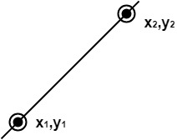 DDA Algorithm
DDA stands for Digital Differential Analyzer. It is an incremental method of scan conversion of line. In this method calculation is performed at each step but by using results of previous steps.
Suppose at step i, the pixels is (x_{i},y_{i})
The line of equation for step i
y_{i}=mx_{i+b}......................equation 1
Next value will be
y_{i+1}=m_{xi+1}+b.................equation 2
m =
y_{i+1}-y_{i}=∆y.......................equation 3
y_{i+1}-x_{i}=∆x......................equation 4
y_{i+1}=y_{i}+∆y
∆y=m∆x
y_{i+1}=y_{i}+m∆x
∆x=∆y/m
x_{i+1}=x_{i}+∆x
x_{i+1}=x_{i}+∆y/m
Case1: When |M|<1 then (assume that x₁<x₂₎
_{x= x1,y=y1 set ∆x=1}
_{yi+1=y1+m, x=x+1}
_{Until x = x2</x}
Case2: When |M|<1 then (assume that y1<y2)
_{x= x1,y=y1 set ∆y=1}
_{xi+1=, y=y+1}
_{Until y → y2</y}

_{Advantage:}
- It is a faster method than method of using direct use of line equation.
- This method does not use multiplication theorem.
- It allows us to detect the change in the value of x and y ,so plotting of same point twice is not possible.
- This method gives overflow indication when a point is repositioned.
- It is an easy method because each step involves just two additions.

_{Disadvantage:}
- It involves floating point additions rounding off is done. Accumulations of round off error cause accumulation of error.
- Rounding off operations and floating point operations consumes a lot of time.
- It is more suitable for generating line using the software. But it is less suited for hardware implementation.

_{DDA Algorithm:}
_{Step1: Start Algorithm}
Step2: Declare x1,y1,x2,y2,dx,dy,x,y as integer variables.
Step3: Enter value of x1,y1,x2,y2.
_{Step4: Calculate dx = x2-x1}
_{Step5: Calculate dy = y2-y1}
_{Step6: If ABS (dx) > ABS (dy)}
_{Then step = abs (dx)}
_{Else}
_{Step7: xinc=dx/step}
_{yinc=dy/step}
_{assign x = x1}
_{assign y = y1}
_{Step8: Set pixel (x, y)}
_{Step9: x = x + xinc}
_{y = y + yinc}
Set pixels (Round (x), Round (y))
Step10: Repeat step 9 until x = x2
_{Step11: End Algorithm}
Example: If a line is drawn from (2, 3) to (6, 15) with use of DDA. How many points will needed to generate such line?
Solution: P1 (2,3) P11 (6,15)
_{x1=2}
_{y1=3}
_{x2= 6}
_{y2=15}
_{dx = 6 - 2 = 4}
_{dy = 15 - 3 = 12}
_{m =} 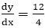
For calculating next value of x takes x = x +
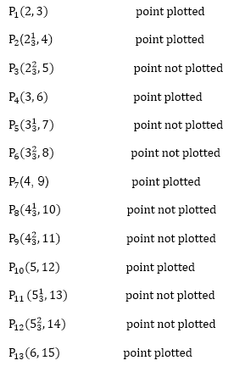
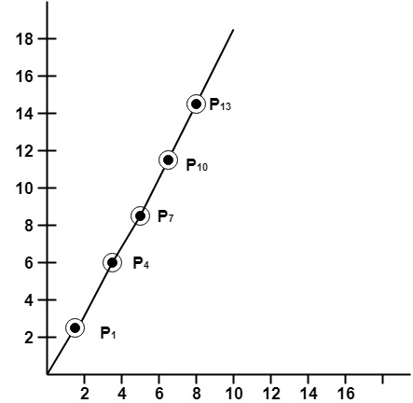

Program to implement DDA Line Drawing Algorithm:
- _{#include<graphics.h>}
- _{#include<conio.h>}
- _{#include<stdio.h>}
- _{void main()}
- {
- _{intgd = DETECT ,gm, i;}
- _{float x, y,dx,dy,steps;}
- _{int x0, x1, y0, y1;}
- initgraph(&gd, &gm, "C:\\TC\\BGI");
- _{setbkcolor(WHITE);}
- x0 = 100 , y0 = 200, x1 = 500, y1 = 300;
- _{dx = (float)(x1 - x0);}
- _{dy = (float)(y1 - y0);}
- _{if(dx>=dy)}
- {
- _{steps = dx;}
- }
- _{else}
- {
- _{steps = dy;}
- }
- _{dx = dx/steps;}
- _{dy = dy/steps;}
- _{x = x0;}
- _{y = y0;}
- _{i = 1;}
- _{while(i<= steps)}
- {
- _{putpixel(x, y, RED);}
- _{x += dx;}
- _{y += dy;}
- _{i=i+1;}
- }
- _{getch();}
- _{closegraph();}
- }
_{Output:}
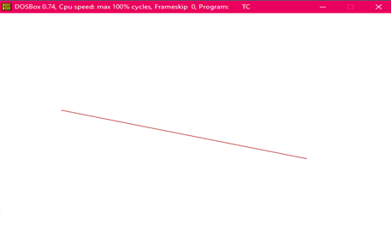

_{Symmetrical DDA:}
The Digital Differential Analyzer (DDA) generates lines from their differential equations. The equation of a straight line is
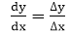
The DDA works on the principle that we simultaneously increment x and y by small steps proportional to the first derivatives of x and y. In this case of a straight line, the first derivatives are constant and are proportional to ∆x and ∆y . Therefore, we could generate a line by incrementing x and y by ϵ ∆x and ϵ ∆y, where ϵ is some small quantity. There are two ways to generate points
1. By rounding to the nearest integer after each incremental step, after rounding we display dots at the resultant x and y.
2. An alternative to rounding the use of arithmetic overflow: x and y are kept in registers that have two parts, integer and fractional. The incrementing values, which are both less than unity, are repeatedly added to the fractional parts and whenever the results overflows, the corresponding integer part is incremented. The integer parts of the x and y registers are used in plotting the line. In the case of the symmetrical DDA, we choose ε=2^{-n}_{,where 2}^{n-1}_{≤max (|∆x|,|∆y|)<2}^{π}
A line drawn with the symmetrical DDA is shown in fig:
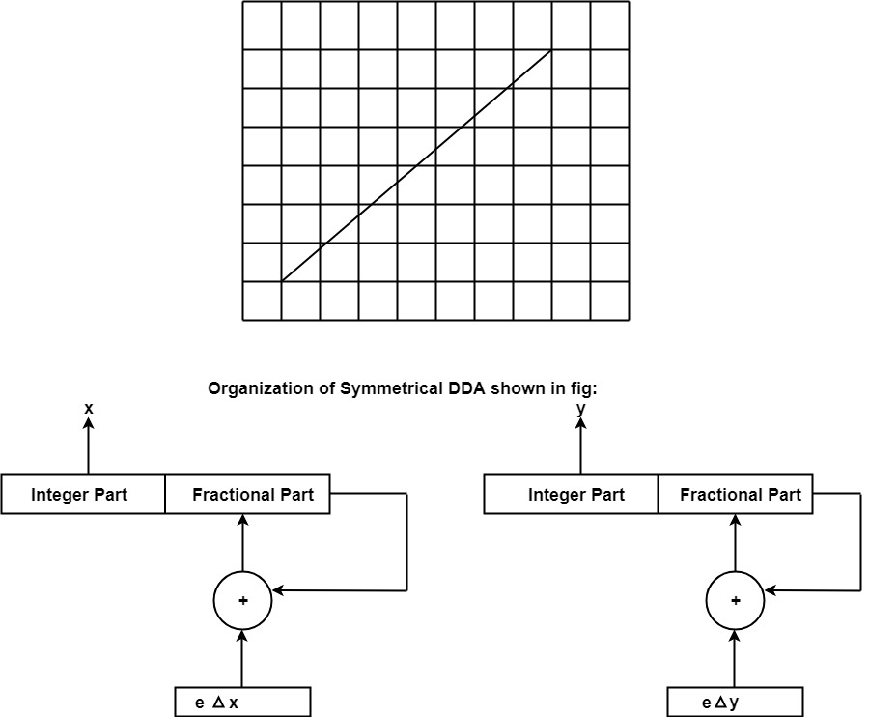
Example: If a line is drawn from (0, 0) to (10, 5) with a symmetrical DDA
1. How many iterations are performed?
2. How many different points will be generated?
_{Solutions: Given: P}¹ _{(0,0) P}² _{(10,5)}
_{x}¹₌₀
_{y}¹₌₀
_{x}²₌₁₀
_{y}²₌₅
_{dx = 10 - 0 = 10}
_{dy = 5 - 0 = 0}
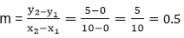
_{P}¹ (0,0) will be considered starting points
_{P}³ (1,0.5) point not plotted
_{P}⁴ (2, 1) point plotted
_{P}⁵ (3, 1.5) point not plotted
_{P}⁶ (4,2) point plotted
_{P}⁷ (5,2.5) point not plotted
_{P}⁸ (6,3) point plotted
_{P}⁹ (7,3.5) point not plotted
_{P}¹⁰ (8, 4) point plotted
_{P}¹¹ (9,4.5) point not plotted
_{P}¹² (10,5) point plotted
Following Figure show line plotted using these points.
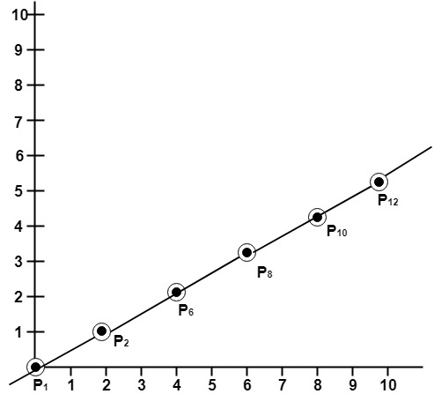

Bresenham's Line Algorithm
This algorithm is used for scan converting a line. It was developed by Bresenham. It is an efficient method because it involves only integer addition, subtractions, and multiplication operations. These operations can be performed very rapidly so lines can be generated quickly.
In this method, next pixel selected is that one who has the least distance from true line.
The method works as follows:
Assume a pixel P₁'(x₁',y₁'),then select subsequent pixels as we work our may to the night, one pixel position at a time in the horizontal direction toward P₂'(x₂',y₂').
Once a pixel in choose at any step
The next pixel is
- Either the one to its right (lower-bound for the line)
- One top its right and up (upper-bound for the line)
The line is best approximated by those pixels that fall the least distance from the path between P₁',P₂'.
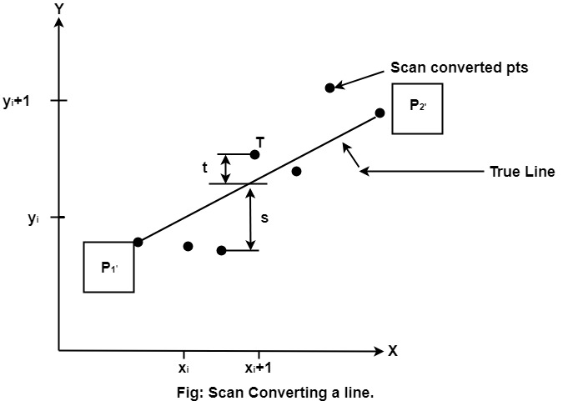
To chooses the next one between the bottom pixel S and top pixel T.
If S is chosen
We have x_{i+1}=x_{i}+1 and y_{i+1}=y_{i}
If T is chosen
We have x_{i+1}=x_{i}+1 and y_{i+1}=y_{i}+1
The actual y coordinates of the line at x = x_{i+1}is
y=mx_{i+1}+b
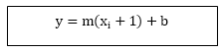
The distance from S to the actual line in y direction
s = y-y_{i}
The distance from T to the actual line in y direction
t = (y_{i}+1)-y
Now consider the difference between these 2 distance values
s - t
When (s-t) <0 ⟹ s < t
The closest pixel is S
When (s-t) ≥0 ⟹ s < t
The closest pixel is T
This difference is
s-t = (y-yi)-[(yi+1)-y]
= 2y - 2yi -1
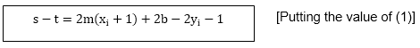
Substituting m by and introducing decision variable
d_{i}=△x (s-t)
d_{i}=△x (2 (x_{i}+1)+2b-2y_{i}-1)
=2△xy_{i}-2△y-1△x.2b-2y_{i}△x-△x
d_{i}=2△y.x_{i}-2△x.y_{i}+c
Where c= 2△y+△x (2b-1)
We can write the decision variable d_{i+1} for the next slip on
d_{i+1}=2△y.x_{i+1}-2△x.y_{i+1}+c
d_{i+1}-d_{i}=2△y.(x_{i+1}-x_{i})- 2△x(y_{i+1}-y_{i})
Since x_(i+1)=x_{i}+1,we have
d_{i+1}+d_{i}=2△y.(x_{i}+1-x_{i})- 2△x(y_{i+1}-y_{i})
Special Cases
If chosen pixel is at the top pixel T (i.e., d_{i}≥0)⟹ y_{i+1}=y_{i}+1
d_{i+1}=d_{i}+2△y-2△x
If chosen pixel is at the bottom pixel T (i.e., d_{i}<0)⟹ y_{i+1}=y_{i}
d_{i+1}=d_{i}+2△y
Finally, we calculate d₁
d₁=△x[2m(x₁+1)+2b-2y₁-1]
d₁=△x[2(mx₁+b-y₁)+2m-1]
Since mx₁+b-y_{i}=0 and m = , we have
d₁=2△y-△x

Advantage:
1. It involves only integer arithmetic, so it is simple.
2. It avoids the generation of duplicate points.
3. It can be implemented using hardware because it does not use multiplication and division.
4. It is faster as compared to DDA (Digital Differential Analyzer) because it does not involve floating point calculations like DDA Algorithm.

Disadvantage:
1. This algorithm is meant for basic line drawing only Initializing is not a part of Bresenham's line algorithm. So to draw smooth lines, you should want to look into a different algorithm.

Bresenham's Line Algorithm:
Step1: Start Algorithm
Step2: Declare variable x₁,x₂,y₁,y₂,d,i₁,i₂,dx,dy
Step3: Enter value of x₁,y₁,x₂,y₂
Where x₁,y₁are coordinates of starting point
And x₂,y₂ are coordinates of Ending point
Step4: Calculate dx = x₂-x₁
Calculate dy = y₂-y₁
Calculatei₁=2*dy
Calculate i₂=2*(dy-dx)
Calculate d=i₁-dx
Step5: Consider (x, y) as starting point and x_{end}as maximum possible value of x.
If dx < 0
Then x = x₂
y = y₂
x_{end}=x₁
If dx > 0
Then x = x₁
y = y₁
x_{end}=x₂
Step6: Generate point at (x,y)coordinates.
Step7: Check if whole line is generated.
If x > = x_{end}
Stop.
Step8: Calculate co-ordinates of the next pixel
If d < 0
Then d = d + i₁
If d ≥ 0
Then d = d + i₂
Increment y = y + 1
Step9: Increment x = x + 1
Step10: Draw a point of latest (x, y) coordinates
Step11: Go to step 7
Step12: End of Algorithm
Example: Starting and Ending position of the line are (1, 1) and (8, 5). Find intermediate points.
Solution: x₁=1
y₁=1
x₂=8
y₂=5
dx= x₂-x₁=8-1=7
dy=y₂-y₁=5-1=4
I₁=2* ∆y=2*4=8
I₂=2*(∆y-∆x)=2*(4-7)=-6
d = I₁-∆x=8-7=1
x | y | d=d+I₁ or I₂
1 | 1 | d+I₂=1+(-6)=-5
2 | 2 | d+I₁=-5+8=3
3 | 2 | d+I₂=3+(-6)=-3
4 | 3 | d+I₁=-3+8=5
5 | 3 | d+I₂=5+(-6)=-1
6 | 4 | d+I₁=-1+8=7
7 | 4 | d+I₂=7+(-6)=1
8 | 5
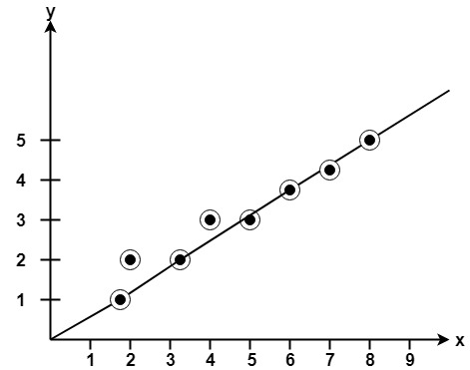

Program to implement Bresenham's Line Drawing Algorithm:
- #include<stdio.h>
- #include<graphics.h>
- void drawline(int x0, int y0, int x1, int y1)
- {
- int dx, dy, p, x, y;
- dx=x1-x0;
- dy=y1-y0;
- x=x0;
- y=y0;
- p=2*dy-dx;
- while(x<x1)
- {
- if(p>=0)
- {
- putpixel(x,y,7);
- y=y+1;
- p=p+2*dy-2*dx;
- }
- else
- {
- putpixel(x,y,7);
- p=p+2*dy;}
- x=x+1;
- }
- }
- int main()
- {
- int gdriver=DETECT, gmode, error, x0, y0, x1, y1;
- initgraph(&gdriver, &gmode, "c:\\turboc3\\bgi");
- printf("Enter co-ordinates of first point: ");
- scanf("%d%d", &x0, &y0);
- printf("Enter co-ordinates of second point: ");
- scanf("%d%d", &x1, &y1);
- drawline(x0, y0, x1, y1);
- return 0;
- }
Output:
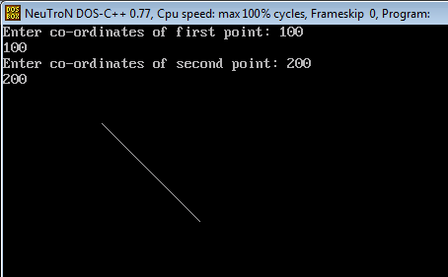

Differentiate between DDA Algorithm and Bresenham's Line Algorithm:
DDA Algorithm | Bresenham's Line Algorithm
1. DDA Algorithm use floating point, i.e., Real Arithmetic. | 1. Bresenham's Line Algorithm use fixed point, i.e., Integer Arithmetic
2. DDA Algorithms uses multiplication & division its operation | 2.Bresenham's Line Algorithm uses only subtraction and addition its operation
3. DDA Algorithm is slowly than Bresenham's Line Algorithm in line drawing because it uses real arithmetic (Floating Point operation) | 3. Bresenham's Algorithm is faster than DDA Algorithm in line because it involves only addition & subtraction in its calculation and uses only integer arithmetic.
4. DDA Algorithm is not accurate and efficient as Bresenham's Line Algorithm. | 4. Bresenham's Line Algorithm is more accurate and efficient at DDA Algorithm.
5.DDA Algorithm can draw circle and curves but are not accurate as Bresenham's Line Algorithm | 5. Bresenham's Line Algorithm can draw circle and curves with more accurate than DDA Algorithm.

Defining a Circle:
Circle is an eight-way symmetric figure. The shape of circle is the same in all quadrants. In each quadrant, there are two octants. If the calculation of the point of one octant is done, then the other seven points can be calculated easily by using the concept of eight-way symmetry.
For drawing, circle considers it at the origin. If a point is P₁(x, y), then the other seven points will be
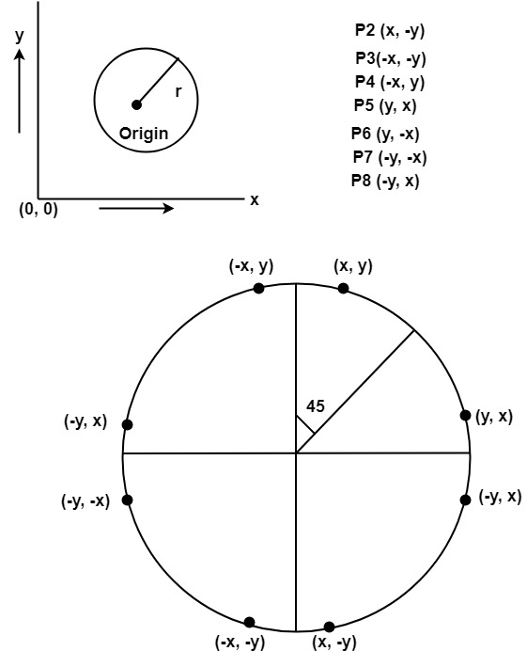
So we will calculate only 45°arc. From which the whole circle can be determined easily.
If we want to display circle on screen then the putpixel function is used for eight points as shown below:
putpixel (x, y, color)
putpixel (x, -y, color)
putpixel (-x, y, color)
putpixel (-x, -y, color)
putpixel (y, x, color)
putpixel (y, -x, color)
putpixel (-y, x, color)
putpixel (-y, -x, color)
Example: Let we determine a point (2, 7) of the circle then other points will be (2, -7), (-2, -7), (-2, 7), (7, 2), (-7, 2), (-7, -2), (7, -2)
These seven points are calculated by using the property of reflection. The reflection is accomplished in the following way:
The reflection is accomplished by reversing x, y co-ordinates.
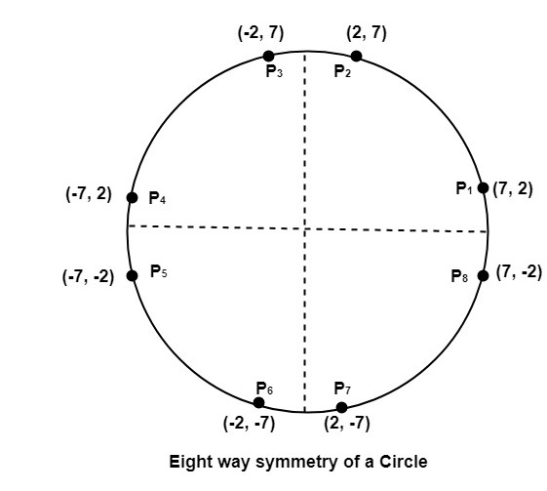
There are two standards methods of mathematically defining a circle centered at the origin.
- Defining a circle using Polynomial Method
- Defining a circle using Polar Co-ordinates

Bresenham's Circle Algorithm:
Scan-Converting a circle using Bresenham's algorithm works as follows: Points are generated from 90° to 45°, moves will be made only in the +x & -y directions as shown in fig:
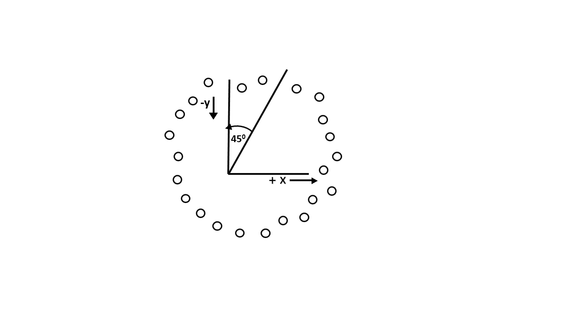
The best approximation of the true circle will be described by those pixels in the raster that falls the least distance from the true circle. We want to generate the points from
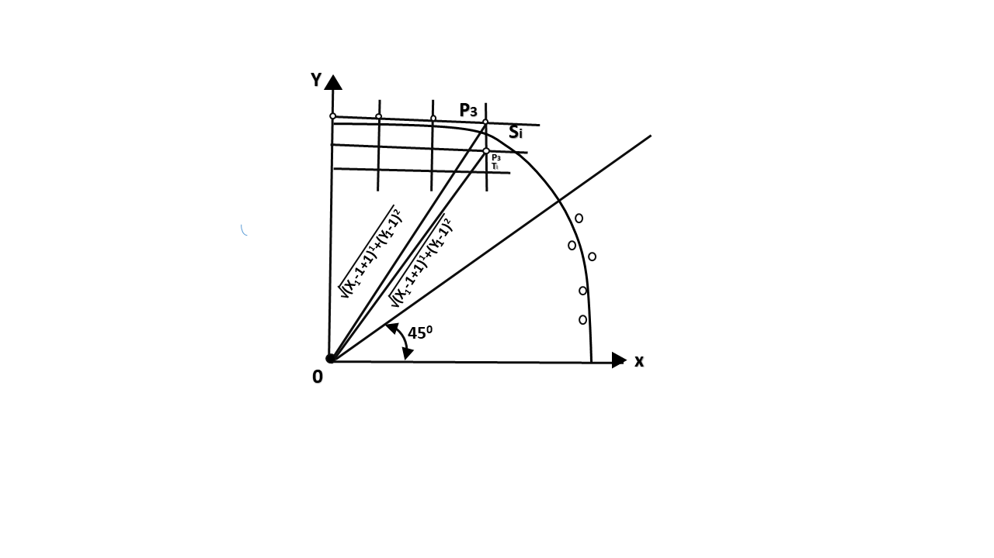
90° to 45°. Assume that the last scan-converted pixel is P₁ as shown in fig. Each new point closest to the true circle can be found by taking either of two actions.
- Move in the x-direction one unit or
- Move in the x- direction one unit & move in the negative y-direction one unit.
Let D (S_{i}) is the distance from the origin to the true circle squared minus the distance to point P₃ squared. D (T_{i}) is the distance from the origin to the true circle squared minus the distance to point P₂ squared. Therefore, the following expressions arise.
D (S_{i})=(x_{i-1}+1)²+ y_{i-1}² -r²
D (T_{i})=(x_{i-1}+1)²+(y_{i-1} -1)²-r²
Since D (S_{i}) will always be +ve & D (T_{i}) will always be -ve, a decision variable d may be defined as follows:
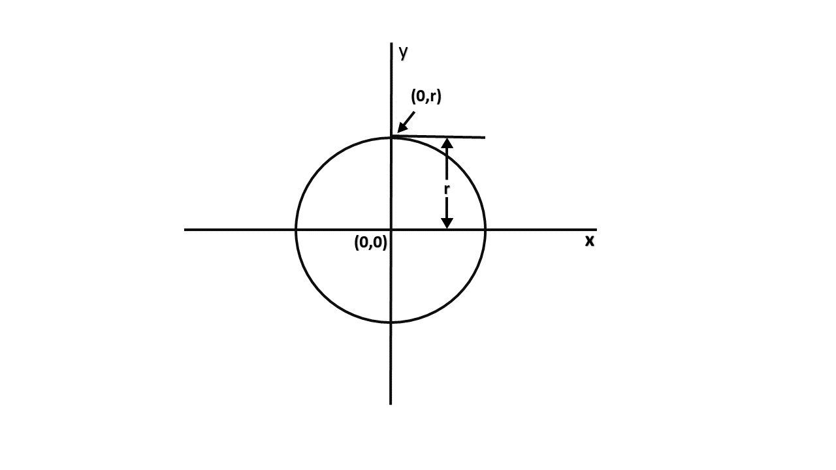
d_{i}=D (S_{i} )+ D (T_{i})
Therefore,
d_{i}=(x_{i-1}+1)²+ y_{i-1}² -r²+(x_{i-1}+1)²+(y_{i-1} -1)²-r²
From this equation, we can drive initial values of d_{i} as
If it is assumed that the circle is centered at the origin, then at the first step x = 0 & y = r.
Therefore,
d_{i}=(0+1)²+r² -r²+(0+1)²+(r-1)²-r²
=1+1+r²-2r+1-r²
= 3 - 2r
Thereafter, if d_i<0,then only x is incremented.
x_{i+1}=x_{i+1} d_{i+1}=d_{i}+ 4x_{i}+6
& if d_{i}≥0,then x & y are incremented
x_{i+1}=x_{i+1} y_{i+1} =y_{i}+ 1
d_{i+1}=d_{i}+ 4 (x_{i}-y_{i})+10

Bresenham's Circle Algorithm:
Step1: Start Algorithm
Step2: Declare p, q, x, y, r, d variables
p, q are coordinates of the center of the circle
r is the radius of the circle
Step3: Enter the value of r
Step4: Calculate d = 3 - 2r
Step5: Initialize x=0
&nbsy= r
Step6: Check if the whole circle is scan converted
If x > = y
Stop
Step7: Plot eight points by using concepts of eight-way symmetry. The center is at (p, q). Current active pixel is (x, y).
putpixel (x+p, y+q)
putpixel (y+p, x+q)
putpixel (-y+p, x+q)
putpixel (-x+p, y+q)
putpixel (-x+p, -y+q)
putpixel (-y+p, -x+q)
putpixel (y+p, -x+q)
putpixel (x+p, -y-q)
Step8: Find location of next pixels to be scanned
If d < 0
then d = d + 4x + 6
increment x = x + 1
If d ≥ 0
then d = d + 4 (x - y) + 10
increment x = x + 1
decrement y = y - 1
Step9: Go to step 6
Step10: Stop Algorithm
Example: Plot 6 points of circle using Bresenham Algorithm. When radius of circle is 10 units. The circle has centre (50, 50).
Solution: Let r = 10 (Given)
Step1: Take initial point (0, 10)
d = 3 - 2r
d = 3 - 2 * 10 = -17
d < 0 ∴ d = d + 4x + 6
= -17 + 4 (0) + 6
= -11
Step2: Plot (1, 10)
d = d + 4x + 6 (∵ d < 0)
= -11 + 4 (1) + 6
= -1
Step3: Plot (2, 10)
d = d + 4x + 6 (∵ d < 0)
= -1 + 4 x 2 + 6
= 13
Step4: Plot (3, 9) d is > 0 so x = x + 1, y = y - 1
d = d + 4 (x-y) + 10 (∵ d > 0)
= 13 + 4 (3-9) + 10
= 13 + 4 (-6) + 10
= 23-24=-1
Step5: Plot (4, 9)
d = -1 + 4x + 6
= -1 + 4 (4) + 6
= 21
Step6: Plot (5, 8)
d = d + 4 (x-y) + 10 (∵ d > 0)
= 21 + 4 (5-8) + 10
= 21-12 + 10 = 19
So P₁ (0,0)⟹(50,50)
P₂ (1,10)⟹(51,60)
P₃ (2,10)⟹(52,60)
P₄ (3,9)⟹(53,59)
P₅ (4,9)⟹(54,59)
P₆ (5,8)⟹(55,58)

Program to draw a circle using Bresenham's circle drawing algorithm:
- #include <graphics.h>
- #include <stdlib.h>
- #include <stdio.h>
- #include <conio.h>
- #include <math.h>

- void EightWaySymmetricPlot(int xc,int yc,int x,int y)
- {
- putpixel(x+xc,y+yc,RED);
- putpixel(x+xc,-y+yc,YELLOW);
- putpixel(-x+xc,-y+yc,GREEN);
- putpixel(-x+xc,y+yc,YELLOW);
- putpixel(y+xc,x+yc,12);
- putpixel(y+xc,-x+yc,14);
- putpixel(-y+xc,-x+yc,15);
- putpixel(-y+xc,x+yc,6);
- }

- void BresenhamCircle(int xc,int yc,int r)
- {
- int x=0,y=r,d=3-(2*r);
- EightWaySymmetricPlot(xc,yc,x,y);

- while(x<=y)
- {
- if(d<=0)
- {
- d=d+(4*x)+6;
- }
- else
- {
- d=d+(4*x)-(4*y)+10;
- y=y-1;
- }
- x=x+1;
- EightWaySymmetricPlot(xc,yc,x,y);
- }
- }

- int main(void)
- {
- /* request auto detection */
- int xc,yc,r,gdriver = DETECT, gmode, errorcode;
- /* initialize graphics and local variables */
- initgraph(&gdriver, &gmode, "C:\\TURBOC3\\BGI");

- /* read result of initialization */
- errorcode = graphresult();

- if (errorcode != grOk) /* an error occurred */
- {
- printf("Graphics error: %s\n", grapherrormsg(errorcode));
- printf("Press any key to halt:");
- getch();
- exit(1); /* terminate with an error code */
- }
- printf("Enter the values of xc and yc :");
- scanf("%d%d",&xc,&yc);
- printf("Enter the value of radius :");
- scanf("%d",&r);
- BresenhamCircle(xc,yc,r);

- getch();
- closegraph();
- return 0;
- }
Output:

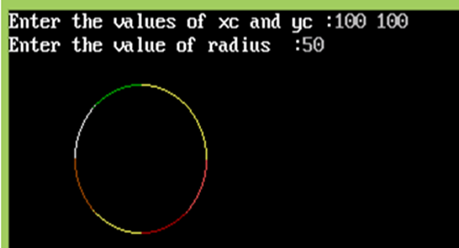 MidPoint Circle Algorithm
It is based on the following function for testing the spatial relationship between the arbitrary point (x, y) and a circle of radius r centered at the origin:
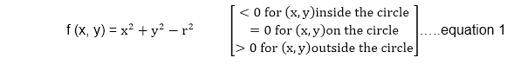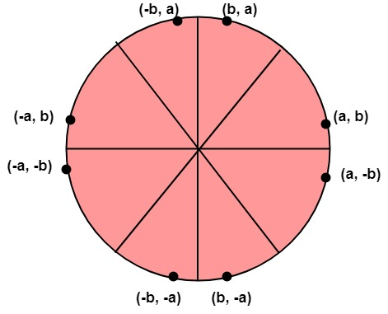
Now, consider the coordinates of the point halfway between pixel T and pixel S
This is called midpoint (x_{i+1},y_{i}-) and we use it to define a decision parameter:
P_{i}=f (x_{i+1},y_{i}-) = (x_{i+1})²+(y_{i}-)²-r² ...............equation 2
If P_{i} is -ve ⟹midpoint is inside the circle and we choose pixel T
If P_{i} is+ve ⟹midpoint is outside the circle (or on the circle)and we choose pixel S.
The decision parameter for the next step is:
P_{i+1}=(x_{i+1}+1)²+(y_{i+1}-)²- r²............equation 3
Since x_{i+1}=x_{i+1}, we have
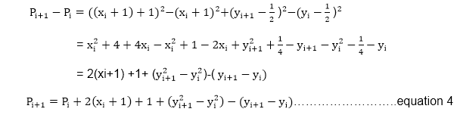
If pixel T is choosen ⟹P_{i}<0
We have y_{i+1}=y_{i}
If pixel S is choosen ⟹P_{i}≥0
We have y_{i+1}=y_{i}-1
We can continue to simplify this in n terms of (x_{i},y_{i}) and get
Now, initial value of P_{i} (0,r)from equation 2
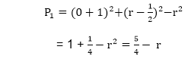
We can put ≅1
∴r is an integer
So, P₁=1-r

Algorithm:
Step1: Put x =0, y =r in equation 2
We have p=1-r
Step2: Repeat steps while x ≤ y
Plot (x, y)
If (p<0)
Then set p = p + 2x + 3
Else
p = p + 2(x-y)+5
y =y - 1 (end if)
x =x+1 (end loop)
Step3: End

Program to draw a circle using Midpoint Algorithm:
- #include <graphics.h>
- #include <stdlib.h>
- #include <math.h>
- #include <stdio.h>
- #include <conio.h>
- #include <iostream.h>

- class bresen
- {
- float x, y,a, b, r, p;
- public:
- void get ();
- void cal ();
- };
- void main ()
- {
- bresen b;
- b.get ();
- b.cal ();
- getch ();
- }
- Void bresen :: get ()
- {
- cout<<"ENTER CENTER AND RADIUS";
- cout<< "ENTER (a, b)";
- cin>>a>>b;
- cout<<"ENTER r";
- cin>>r;
- }
- void bresen ::cal ()
- {
- /* request auto detection */
- int gdriver = DETECT,gmode, errorcode;
- int midx, midy, i;
- /* initialize graphics and local variables */
- initgraph (&gdriver, &gmode, " ");
- /* read result of initialization */
- errorcode = graphresult ();
- if (errorcode ! = grOK) /*an error occurred */
- {
- printf("Graphics error: %s \n", grapherrormsg (errorcode);
- printf ("Press any key to halt:");
- getch ();
- exit (1); /* terminate with an error code */
- }
- x=0;
- y=r;
- putpixel (a, b+r, RED);
- putpixel (a, b-r, RED);
- putpixel (a-r, b, RED);
- putpixel (a+r, b, RED);
- p=5/4)-r;
- while (x<=y)
- {
- If (p<0)
- p+= (4*x)+6;
- else
- {
- p+=(2*(x-y))+5;
- y--;
- }
- x++;
- putpixel (a+x, b+y, RED);
- putpixel (a-x, b+y, RED);
- putpixel (a+x, b-y, RED);
- putpixel (a+x, b-y, RED);
- putpixel (a+x, b+y, RED);
- putpixel (a+x, b-y, RED);
- putpixel (a-x, b+y, RED);
- putpixel (a-x, b-y, RED);
- }
- }
Output:

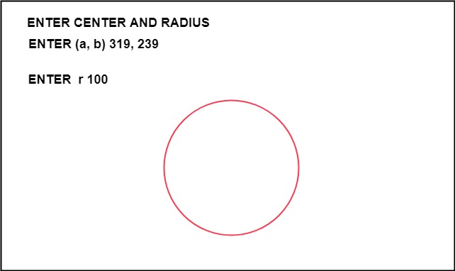 Types of Polygons

ronilpatil

• Read
• Discuss

Types of Polygons classify all polygons based on various parameters. As we know, a polygon is a closed figure consisting only of straight lines on its edges. In other words, polygons are closed figures made up of more than 2 line segments on a 2-dimensional plane. The word Polygon is made up of two words, the first is “poly” which means many and the second is “gons” which means sides, thus polygon means many sides. Polygons are made with two components, the first is the vertex and the second is an edge.
In this article, we will discuss the classification of Polygons which include, convex and concave polygons, simple and complex polygons, regular and irregular polygons, etc. So let’s start learning about the various types of polygons in this article.

How many Types of Polygons?
Polygons can be classified based on various different parameters, some of these parameters are:
- Based on Boundary of the Polygon
- Based on the Side Length
- Based on Interior Angle
- Based on Sides
Let’s discuss types of polygons based on these parameters in detail as follows:

Types of Polygons Based on Boundary of the Polygon
- Simple Polygon
- Complex Polygon

Simple Polygon
A simple Polygon is a closed geometric shape which is constructed using non-intersecting line segments. In simple words, a two-dimensional figure with sides that do not intersect with each other is called a simple polygon. Some of the common examples of simple polygons are triangles, squares, rectangles, pentagons, hexagons, and many more.
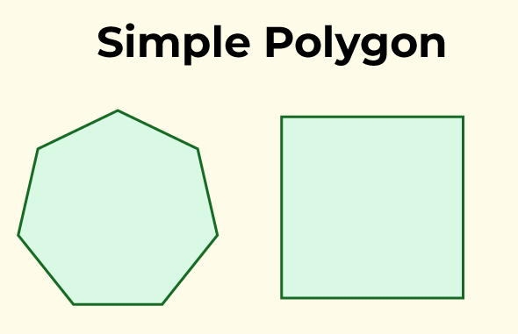

Complex Polygon
A complex polygon is a two-dimensional geometric shape that has sides consisting of straight line segments and may have self-intersections or holes. Unlike simple polygons, which do not cross themselves, complex polygons can have edges that intersect each other within the polygon’s boundary, resulting in a more intricate and irregular shape.
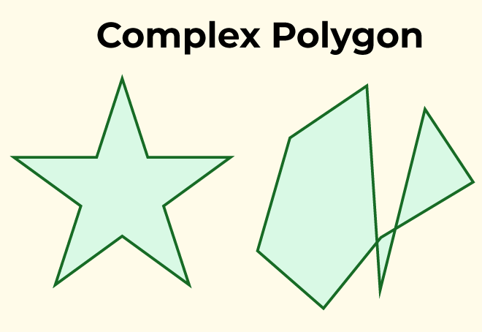

Complex polygons can be formed by combining simple polygons or by adding cut-outs (holes) within a simple polygon. These cut-outs create regions within the polygon that are not part of the main boundary. The inclusion of self-intersections and holes makes complex polygons more challenging to work with and analyze compared to simple polygons.

Types of Polygons Based on the Side Length
Based on the length of sides, the polygons are classified as follows:
- Regular Polygon
- Irregular Polygon

Regular Polygon
If all the sides and interior angles of the polygon are equal or if a polygon is equiangular and equilateral, then the polygon will be known as a regular polygon. Example square, rhombus, equilateral triangle, etc.
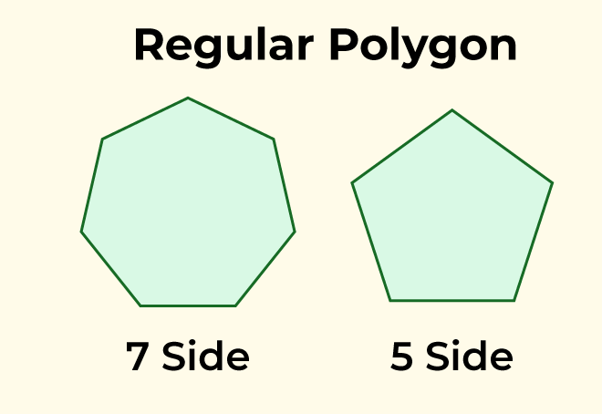

Irregular Polygon
If all the sides and the interior angles of the polygon are of different measure, then the polygon will be known as an irregular polygon. For example scalene triangle, rectangle, kite, etc.
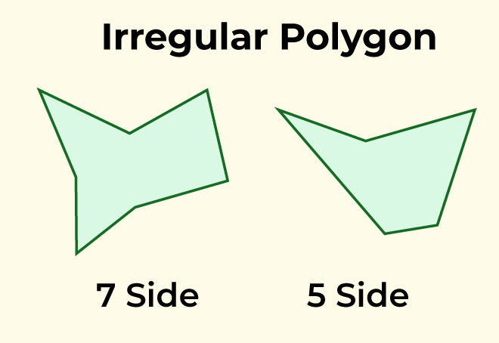

Types of Polygons Based on Interior Angle
Based on the measurement of interior angles the polygons are classified as follows:
- Convex Polygon
- Concave Polygon

Convex Polygon
If all the interior angles of a polygon are strictly less than 180° or if a line segment between two points on the boundary does not go outside the polygon, then the polygon will be known as a convex polygon.
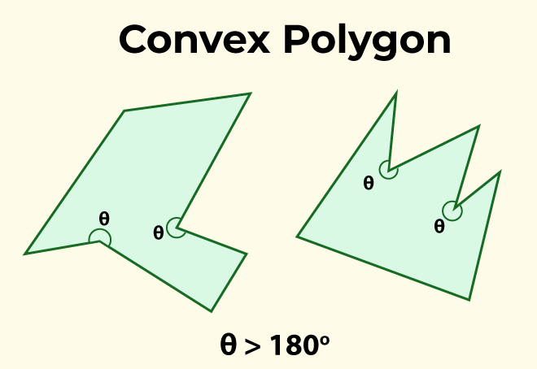

Concave Polygon
If one or more interior angles of a polygon are more than 180° degrees or a polygon contains at least one reflex interior angle, then the polygon will be known as a concave polygon. This polygon can have at least four sides.
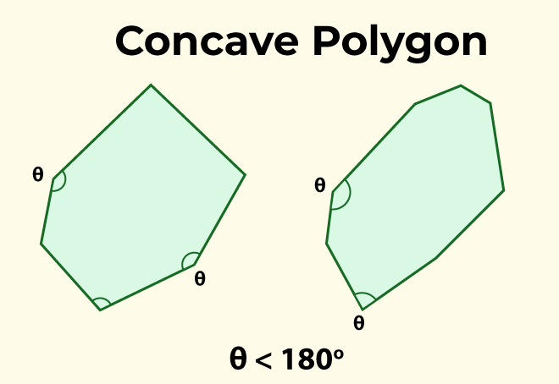

Types of Polygons Based on Sides
Polygons are classified based on the number of sides or vertices they have. So, some of the polygons are:
- Triangles
- Quadrilateral
- Pentagon
- Hexagon
- So on . . .
All of these polygons are given in the following table:
Polygon | Shape | No. of sides | No. of Diagonal | No. of vertices | Interior Angle | Exterior Angle
Triangle | 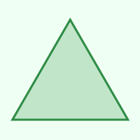 | 3 | 0 | 3 | 60° | 120°
Quadrilateral |  | 4 | 2 | 4 | 90° | 90°
Pentagon | 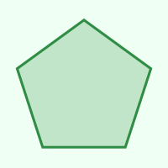 | 5 | 5 | 5 | 108° | 72°
Hexagon | 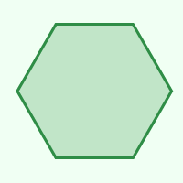 | 6 | 9 | 6 | 120° | 60°
Heptagon | 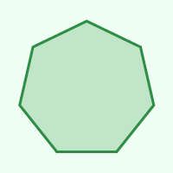 | 7 | 14 | 7 | 128.571° | 51.429°
Octagon | 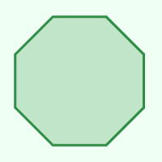 | 8 | 20 | 8 | 135° | 45°
Nonagon | 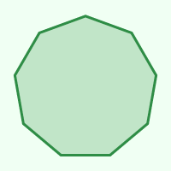 | 9 | 27 | 9 | 140° | 40°
Decagon | 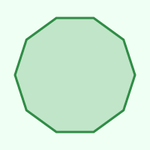 | 10 | 35 | 10 | 144° | 36°
Hendecagon | 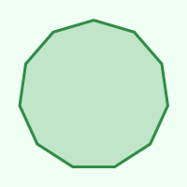 | 11 | 44 | 11 | 147.273° | 32.727°
Dodecagon | 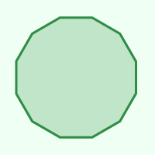 | 12 | 54 | 12 | 150° | 30°
Triskaidecagon | 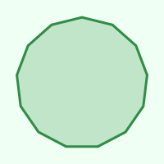 | 13 | 65 | 13 | 158.308° | 27.692°
Tetrakaidecagon | 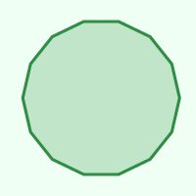 | 14 | 77 | 14 | 154.286° | 25.714°
Pentadecagon | 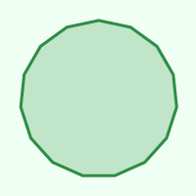 | 15 | 90 | 15 | 156° | 24°

Triangles(3-gon)
A triangle is a polygon, it is formed with the help of three-line segments intersecting each other, so a triangle has 3 vertices, 3 edges, and 3 angles. The triangles are classified into different types, based on the sides and angles.
Some properties of the triangle:
- Area of Triangle: 1/2× base × height
- In a triangle, the sum of all the interior angles of a triangle is 180o.
- The side opposite to the largest angle is the largest side of the triangle.
- The perimeter of a triangle is equal to the sum of the lengths of all three sides of the triangle.

Types: Based on Sides
- Equilateral triangle: If a triangle has all sides equal and angles of equal measure then such types of triangles are known as equilateral triangles.
- Isosceles triangle: If any triangle having any 2 sides equal and angles opposite to the equal sides are equal, then such types of triangles are known as isosceles triangles.
- Scalene triangle: If a triangle has all the 3 sides unequal, then such type of triangles are known as a scalene triangle.
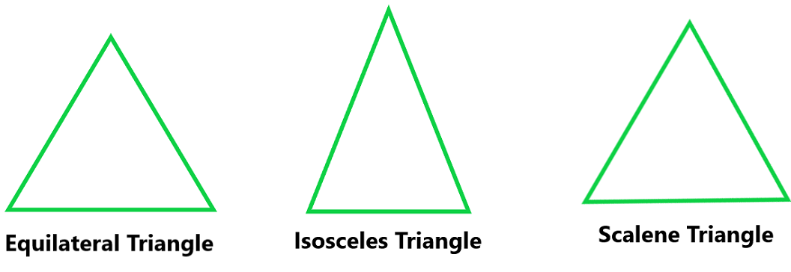

Types: Based on the Angle
- Acute Angled Triangle: A triangle with an angle less than 90° is known as an acute-angle triangle.
- Right Angled Triangle: If any one of the three angles of a triangle is equal to 90° then such type of triangle is known as a right-angle triangle.
- Obtuse Angled Triangle: If any one angle of a triangle is greater than 90°, then such type of triangle is known as an obtuse-angle triangle.
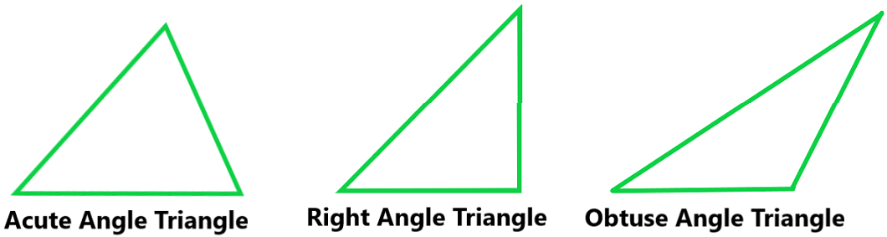

Quadrilaterals (4-gon)
A Quadrilateral is nothing but a polygon having at least 4 sides. A polygon is formed by enclosing four line segments such that they meet at each other at vertices to make 4 or more angles. Examples of Quadrilateral are Square, Rectangle, Parallelogram, Rhombus, Trapezium.
Some properties of a quadrilateral:
- It has four sides.
- It has four vertices.
- In a quadrilateral, the sum of all the interior angles is 360o.
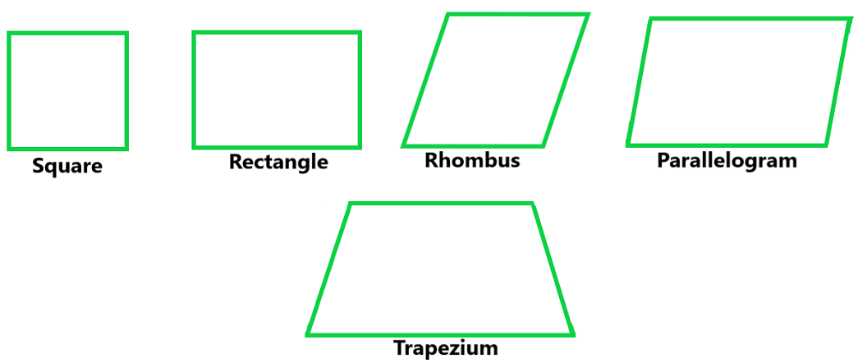
Apart from triangle and quadrilateral there are also other polygons but they don’t have much use in real life.
Read More,
- Polyhedrons
- Diagonal of Polygon

Sample Problems on Types of Polygon
Question 1. Find the exterior angle of a regular hexagon.
Solution:
As we know that, hexagon has 6 sides therefore
Exterior Angle = 360o / n = 360o / 6
Exterior Angle = 60o
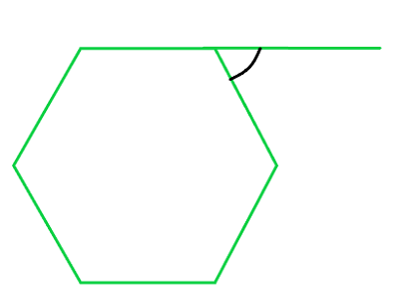
Question 2. Find the interior angle of a regular pentagon.
Solution:
As we know that pentagon has 5 sides, therefore
Exterior Angle = 360o / 5 = 72o
Interior Angle = 180o – 72o = 108o
Question 3. Find each interior angle of a regular decagon.
Solution:
As we know that, decagon has ten sides.
Using angle sum formula,
As we know that,
S = (n − 2) × 180°
Here, n = 10
Therefore,
Sum of angles of decagon = (10 − 2) × 180°
= 8 × 180° = 1440°
As we know that all the interior angles are equal of a regular decagon,
Therefore, the measure of each interior angle of regular decagon = sum of interior angles / number of sides
Interior angle = 1440 / 10 = 144°
Hence, Sum of Interior Angle of decagon is 1440° and each interior angle is of 144°.
Question 4. Find the value of x in the given figure:
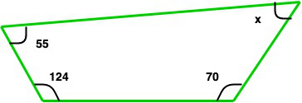
Solution:
As we know that the sum of angles os a quadrilateral = 360o
so, 55o + 124o + 70o + x = 360o
249o + x = 360o
x = 111o
Question 5. Find the value of x in the given figure:
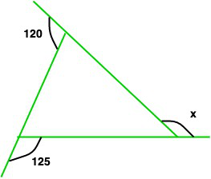
Solution:
As we know that the sum of exterior angles = 360o
So, 120o + 125 + x = 360o
245o + x = 360o
x = 360o – 245o
x = 115o

FAQs on Types of Polygons

1. What is a Polygon?
A polygon is a closed two-dimensional shape with straight sides. It is formed by connecting several line segments, known as edges and the endpoints of those edges are called vertices.

2. How are Polygons Classified based on the Number of Sides they have?
Polygons are classified based on the number of sides they possess. Common classifications include:
- Triangle: 3 sides
- Quadrilateral: 4 sides
- Pentagon: 5 sides
- Hexagon: 6 sides
- Heptagon: 7 sides
- Octagon: 8 sides
- Nonagon: 9 sides
- Decagon: 10 sides
- and so on…

3. What is a Regular Polygon?
A regular polygon is a polygon with all sides of equal length and all angles of equal measure. For example, a regular pentagon has five sides of equal length and five angles of equal measure.

4. Can a Polygon have Concave Sides?
Yes, a polygon can have concave sides. A concave polygon has at least one interior angle greater than 180 degrees, causing one or more sides to “sink inward.”

5. How do you Identify Convex and Concave Polygons?
If the interior angles of any polygon are greater than 180° then the polygon is concave, and if all the interior angles are less than 180° then the polygon is convex.

6. What is a Regular Convex Polygon?
A regular convex polygon is a polygon that is both convex and regular i.e., it has all sides of equal length and all interior angles of equal measure and less than 180°.

7. Are there any Polygons with an Infinite Number of Sides?
Yes, a polygon with an infinite number of sides is called a circle as a circle can be considered a polygon as it meets the definition of a closed two-dimensional shape with straight sides where a number of edges approaches infinity

8. Can a Polygon have Curved Sides?
No, by definition, a polygon has straight sides, thus any shape with curve sides is not a polygon.

9. What is the Sum of the Interior Angles of a Polygon?
The sum of the interior angles of a polygon can be calculated using the formula (n – 2) × 180°, where ‘n’ represents the number of sides of the polygon.

Filled Area Primitives:
Region filling is the process of filling image or region. Filling can be of boundary or interior region as shown in fig. Boundary Fill algorithms are used to fill the boundary and flood-fill algorithm are used to fill the interior.
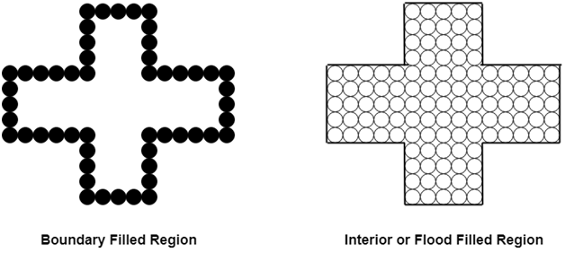

Boundary Filled Algorithm:
This algorithm uses the recursive method. First of all, a starting pixel called as the seed is considered. The algorithm checks boundary pixel or adjacent pixels are colored or not. If the adjacent pixel is already filled or colored then leave it, otherwise fill it. The filling is done using four connected or eight connected approaches.
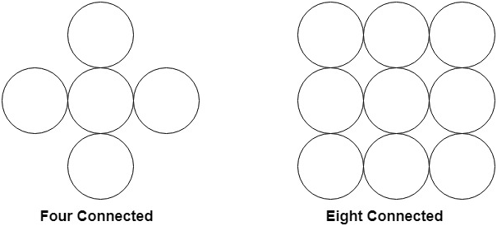
Four connected approaches is more suitable than the eight connected approaches.
1. Four connected approaches: In this approach, left, right, above, below pixels are tested.
2. Eight connected approaches: In this approach, left, right, above, below and four diagonals are selected.
Boundary can be checked by seeing pixels from left and right first. Then pixels are checked by seeing pixels from top to bottom. The algorithm takes time and memory because some recursive calls are needed.

Problem with recursive boundary fill algorithm:
It may not fill regions sometimes correctly when some interior pixel is already filled with color. The algorithm will check this boundary pixel for filling and will found already filled so recursive process will terminate. This may vary because of another interior pixel unfilled.
So check all pixels color before applying the algorithm.

Algorithm:
- Procedure fill (x, y, color, color1: integer)
- int c;
- c=getpixel (x, y);
- if (c!=color) (c!=color1)
- {
- setpixel (x, y, color)
- fill (x+1, y, color, color 1);
- fill (x-1, y, color, color 1);
- fill (x, y+1, color, color 1);
- fill (x, y-1, color, color 1);
- }

Flood Fill Algorithm:
In this method, a point or seed which is inside region is selected. This point is called a seed point. Then four connected approaches or eight connected approaches is used to fill with specified color.
The flood fill algorithm has many characters similar to boundary fill. But this method is more suitable for filling multiple colors boundary. When boundary is of many colors and interior is to be filled with one color we use this algorithm.
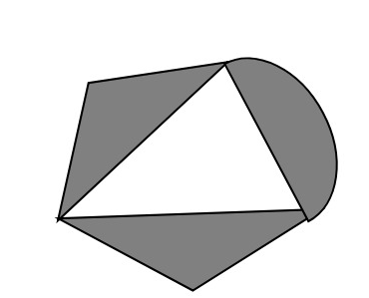
In fill algorithm, we start from a specified interior point (x, y) and reassign all pixel values are currently set to a given interior color with the desired color. Using either a 4-connected or 8-connected approaches, we then step through pixel positions until all interior points have been repainted.

Disadvantage:
- Very slow algorithm
- May be fail for large polygons
- Initial pixel required more knowledge about surrounding pixels.

Algorithm:
- Procedure floodfill (x, y,fill_ color, old_color: integer)
- If (getpixel (x, y)=old_color)
- {
- setpixel (x, y, fill_color);
- fill (x+1, y, fill_color, old_color);
- fill (x-1, y, fill_color, old_color);
- fill (x, y+1, fill_color, old_color);
- fill (x, y-1, fill_color, old_color);
- }
- }

Program1: To implement 4-connected flood fill algorithm:
- #include<stdio.h>
- #include<conio.h>
- #include<graphics.h>
- #include<dos.h>
- void flood(int,int,int,int);
- void main()
- {
- intgd=DETECT,gm;
- initgraph(&gd,&gm,"C:/TURBOC3/bgi");
- rectangle(50,50,250,250);
- flood(55,55,10,0);
- getch();
- }
- void flood(intx,inty,intfillColor, intdefaultColor)
- {
- if(getpixel(x,y)==defaultColor)
- {
- delay(1);
- putpixel(x,y,fillColor);
- flood(x+1,y,fillColor,defaultColor);
- flood(x-1,y,fillColor,defaultColor);
- flood(x,y+1,fillColor,defaultColor);
- flood(x,y-1,fillColor,defaultColor);
- }
- }
Output:


Program2: To implement 8-connected flood fill algorithm:
- #include<stdio.h>
- #include<graphics.h>
- #include<dos.h>
- #include<conio.h>
- void floodfill(intx,inty,intold,intnewcol)
- {
- int current;
- current=getpixel(x,y);
- if(current==old)
- {
- delay(5);
- putpixel(x,y,newcol);
- floodfill(x+1,y,old,newcol);
- floodfill(x-1,y,old,newcol);
- floodfill(x,y+1,old,newcol);
- floodfill(x,y-1,old,newcol);
- floodfill(x+1,y+1,old,newcol);
- floodfill(x-1,y+1,old,newcol);
- floodfill(x+1,y-1,old,newcol);
- floodfill(x-1,y-1,old,newcol);
- }
- }
- void main()
- {
- intgd=DETECT,gm;
- initgraph(&gd,&gm,"C:\\TURBOC3\\BGI");
- rectangle(50,50,150,150);
- floodfill(70,70,0,15);
- getch();
- closegraph();
- }
Output:

Scan Line Polygon Fill Algorithm:
This algorithm lines interior points of a polygon on the scan line and these points are done on or off according to requirement. The polygon is filled with various colors by coloring various pixels.
In above figure polygon and a line cutting polygon in shown. First of all, scanning is done. Scanning is done using raster scanning concept on display device. The beam starts scanning from the top left corner of the screen and goes toward the bottom right corner as the endpoint. The algorithms find points of intersection of the line with polygon while moving from left to right and top to bottom. The various points of intersection are stored in the frame buffer. The intensities of such points is keep high. Concept of coherence property is used. According to this property if a pixel is inside the polygon, then its next pixel will be inside the polygon.
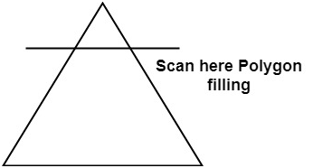

Side effects of Scan Conversion:
1. Staircase or Jagged: Staircase like appearance is seen while the scan was converting line or circle.
2. Unequal Intensity: It deals with unequal appearance of the brightness of different lines. An inclined line appears less bright as compared to the horizontal and vertical line.
